

Imam Abdulrahman Bin Faisal University
College of Computer Science & Information Technology
Department of Computer Science

BCS 202– Software Engineering
Term 2 – 3/5/2026

Software Project Management Plans

For



Version 2.0

Team 4 : CS, 3BM2

Dr. -

Date of preparation: Mar 1, 2026

This Software Project Management Plans (SPMP) was prepared and provided as a deliverable for Software Engineering, BCS 202, Term 2, and it will be used by Dr. Saqib Saeed and the Mizan development team.
This document is based in part on the IEEE Recommended Practice for SPMP Descriptions.
Prepared by :
- Mishal Al-jumaih ID: -

- -: -

- - ID: -

Table of Content
Revision History: 4
Table of Tables 5
Table of Figures 6
1. Project Overview 7
1.1 Purpose, Scope, and Objectives 7
1.2 Assumptions, Constraints and Risks 8
1.3 Project Deliverables 9
1.4 Schedule and Budget Summary 10
1.5 Evolution of the plan 11
1.6 References 11
1.7 Definitions and Acronyms 12
1.8 Document Structure 13
2. Project Organization 14
2.1 External Interfaces 14
2.2 Internal Structure 14
2.3 Roles and Responsibilities 15
3. Managerial Process Plans 16
3.1 Start-up Plan 16
3.1.1 Estimates 16
3.1.2 Staffing 17
3.1.3 Project Staff Training 17
3.2 Work Plan 18
3.2.1 Work Breakdown Structure 18
3.2.2 Schedule Allocation 20
3.2.3 Resource Allocation 22
3.2.4 Budget Allocation 23
3.3 Project Tracking Plan 24
3.3.1 Requirements Management 24
3.3.2 Schedule Control 24
3.3.3 Quality Control 26
3.3.4 Reporting 27
3.3.5 Project Metrics 27
3.4 Risk Management Plan 28
3.5 Project Closeout Plan 30
4. Technical Process Plans 31
4.1 Process Model 31
4.2 Methods, Tools, and Techniques 33
4.3 Infrastructure 34
4.4 Product Acceptance 35
5. Supporting Process Plans 36
5.1 Documentation 36
6. Additional Plans 37

Revision History:

Table 1:Revision History
Name | Date | Reason For Changes | Version
Mishal Al-jumaih | Feb 10, 2026 | Prepared initial version | 0.1
- | Feb 18, 2026 | Added Agile framework, WBS and Roles & Responsibilities | 0.2
- | Feb 28, 2026 | Added Risk Management, Budget and Technical Tools | 0.3
- | Mar 8, 2026 | Review all the images and tables we need | 1.0
Mishal Al-jumaih | Mar 10,2026 | Add all the images and tables that were received | 1.1
- | Mar 13,2026 | Fixing file problems and some formatting issues in IEEE format | 1.2
All Team members | Mar 18,2026 | Complete review and Final review, SPMP completion | 2.0

Table of Tables
Table 1:Revision History 5
Table 2: Expected Document deliverables 10
Table 3: Project Roles and Responsibilities 16
Table 4:human and hardware resources required per phase 23
Table 5:a breakdown of the budget for each stage: 24
Table 6:Risk Management Register (Risk Log) 31
Table 7:the documentation plan in accordance with our Agile team roles. 38

Table of Figures
Figure 1:Internal Structure 14
Figure 2: Gantt Chart-week-1-to-week-6 20
Figure 3: Gantt Chart-week-7-to-week-12 20
Figure 4: Gantt Chart-week-13-to-week-16 21
Figure 5:Scrum Agile Framework 25
Figure 6:Baselines & Deliverables 33
Figure 7:Flow of Information 33

Project Overview
This section is intended to provide an overview of the purpose, scope, and objectives of the project for which this Plan has been formulated, project assumptions and limits, project deliverables, and finally, an overview of project schedule and budget.

Purpose, Scope, and Objectives
    - Purpose:

The "Mizan" project aims to create a personal management tool in the form of a web application that can help individuals manage their financial responsibilities and life commitments and tasks. At present, people are using multiple applications to manage their data, using simple note-taking apps and complex accounting software. The "Mizan" project aims to provide users with a single tool to manage their tasks, expenses, and long-term warranties, e.g., construction materials and car maintenance.
1.1.2 Scope:
- Develop a functional and responsive web-based prototype using Agile Methodology (Scrum).
- Create a unified system of entries, where every entry has "Value" (Costs) and "Duration" (Short/Long Term).
- Develop a dynamic system of tagging (e.g., #HomeRenovation, #CarMaintenance).
- Develop simple reporting to calculate cumulative costs based on specific tags.
Out of Scope:
This project will not include features such as complex and advanced accounting, connections to external bank accounts, and AI-based prediction tools. These features are considered out of scope as they are too complex and challenging to implement within a university environment.

1.1.3 Objectives:

-Dependability & Security: To ensure the security of the user data, particularly the long-term warranty and receipts, by keeping the data safe and stored in the database with zero data loss.

- Efficiency: To ensure the efficiency of the system, which will allow the user to easily create an entry or generate a report without any wastage of resources.

- Usability (Acceptability): To ensure the acceptability of the system, which will be user-friendly and bilingual, designed particularly for the Middle Eastern culture, meeting the requirements of the target users.

-Maintainability: To ensure the maintainability of the system, which will be designed with modules to allow for the addition of more features and the use of the Agile development process

Assumptions, Constraints and Risks

1.2.1 Assumptions:

- The end-users will be able to access computers or smartphones with a reliable internet connection.
- The end-users will be computer literate and will be able to use the web application.
- The university will be providing the free software licenses required, and the development team will be utilizing open-source development tools such as PHP, MySQL, and XAMPP.

1.2.2 Constraints:

- Schedule Constraint: The project development period is strictly limited to the academic semester, which is approximately 15 weeks.
- Budget Constraint: There is a budget set for the project, and the team has to work within the budget constraints.
- Team Constraint: The team consists of 3 students, and therefore the scope has to be managed effectively to avoid overburdening the team.

1.2.3 Risk:

- Estimation Risk (Project Risk): Underestimating the time required for the development of the features such as the dynamic reporting system, which will be included in the Sprints.
- Requirements Risk (Product Risk): Changes to the requirements, which will be imposed on us at a later fee, and which will demand significant changes to the product.
- People Risk: The team members might be unavailable during the critical mid-term examination period, which will cause delays in the Sprints.

Project Deliverables
1.3.1 Document Deliverables:
Table 2: Expected Document deliverables
# | Topics / Deliverables | Date between
1 | Proposal discussion | 1 Feb 2026
2 | Introduction | 16 Feb 2026
3 | Software Project Management plan (SPMP) | 10–20 Mar 2026
4 | project status report 1 | 29 Mar–5 Apr 2026
5 | Software Requirements Specification (SRS) | 19–25 Apr 2026
6 | Submit project status report 2 | 26 Apr–1 May 2026
5 | Software Design Specification (SDS) | 3–9 May 2026
6 | Submit Project Test Plan (STS) | 10–16 May 2026
7 | Project Proposal Final Report | 17–31 May 2026

Schedule and Budget Summary
1.4.1 Schedule Summary:
Project Initiation & Planning – Weeks 1-3 (February 1 – 16, 2026) Submit the project proposal on February 1. Develop the Software Project Management Plan (SPMP) and submit the same between March 10 – 20. Identify the roles and responsibilities of the development team and set up the development environment using XAMPP, MySQL, VS Code, and GitHub. Develop the initial database schema with eight key tables.
Requirements Engineering – Weeks 4 – 6 (February 16 – March 10, 2026)
Create the user stories and populate the product backlog. Develop the Software Requirements Specification (SRS) document as per the course requirements and submit the same. Submit Status Report 1 between March 29 – April 5.
System Design – Weeks 7 – 9 (March – April 2026)
Design the system architecture using the MVC pattern with PHP as the programming language. Create UI/UX wireframes using Figma and database schema diagrams using Draw.io. Develop the Software Design Specification (SDS) document and submit the same between May 3 – 9.
Core Implementation – Sprints 1 – 4, Weeks 4 – 12 (February – May 2026)
Implement the authentication system, dashboard, project, and expense management module during Sprint 1 and 2, respectively. Implement the file upload system, invoices, warranties, email notifications, etc., during Sprint 3, which involves uploading files of up to 500 MB size. Implement the reports, analytics module, etc., using Chart.js, along with the PDF/CSV export feature during Sprint 4
Midterm Examination Period — Weeks 9–12 (April 2026)
Reduce the workload during the academic examination period. Status Report 2 submission between April 26th and May 1st.
Testing & Quality Assurance — Weeks 12–14 (May 2026)
Security audits of the application, i.e., XSS, SQL injection, CSRF attacks, etc., along with cross-browser, mobile responsive tests, etc., are performed during this period. Software Test Specification is prepared during this period, which is to be submitted between May 10th and 16th. The application is deployed onto the cloud server.
Final Submission & Presentation — Weeks 14–16 (May 17–31, 2026)
The entire project is reviewed, along with the completion of the entire project documentation, i.e., SPMP, SRS, SDS, etc., along with the final project report, etc., along with the live presentation of the project before the course instructor, etc., which is to be submitted between May 17th and 31st, 2026.

1.4.2 Budget Summary:
Being a university software project, our software development strategy is focused on low-cost technologies for high performance and reliability. As such, we are using open-source web technologies for development and are keeping a budget for real-world deployment (PSPI):
    - Domain Name Registration: ~100 SAR/year (register a professional domain name like mizan-iau.com).
    - Cloud Web Hosting: ~150 SAR/year (secure a reliable shared hosting or a basic VPS like Hostinger/DigitalOcean for global accessibility).
    - Development Tools: 0 SAR (free tools like VS Code, XAMPP, PhpMyAdmin, MySQL, SSL , cPanel Hosting and GitHub for source control).
    - AI Agent: 431 SAR for Claude Pro (5 months) + 425 SAR for Google AI Pro (5 months).
    - External Device: Huawei Tablet ~600 SAR (for website testing).
    - Personal Devices: 3 Phones, 3 PCs.
- Total Estimated Budget: ~1706 SAR.

Evolution of the plan
This Software Project Management Plan (SPMP) is prepared in accordance with Agile Software Development with Scrum. Therefore, it is expected to evolve in the following ways:
- Sprint Reviews: After every 2-4 weeks of Sprint, we will review our progress in terms of the Mizan prototype.
- Plan Updates: Any change in the plan will be updated here to reflect the current realities.
- Version Control: Every change in the SPMP will increase the number of the Revision History

References

The following documents and materials were used in preparation of this project plan:
1. Course Lectures (BCS 202 - Software Engineering):
- Chapter 1: Introduction (Project attributes & ACM/IEEE Code of Ethics)
- Chapter 2: Software Processes (Incremental Development)
- Chapter 3: Agile Software Development (Scrum methodology & User Stories)
- Chapter 22: Project Management (Risk management & team organization)
- Chapter 23: Project Planning (Agile planning & estimation)
2. IEEE Standard for Software Project Management Plans
3. Mizan Project Proposal Form

Definitions and Acronyms
- SPMP: Software Project Management Plan
- Agile: Software development approach
- Scrum: Agile project management framework
-PSPI: Potentially Shippable Product Increment (A core Scrum concept representing the final working software ready for deployment).
- Sprint: Fixed period (usually 2-4 weeks) in which tasks from Product Backlog are executed
- Product Backlog: Prioritized list of all user stories and features to be included in the final product
- Mizan: Project Name; Arabic for "Scale" or "Balance"
-WBS: Work Breakdown Structure (A hierarchical decomposition of the total scope of work to be carried out by the project team).
-CCB: Change Control Board (The group responsible for approving or rejecting changes to the project requirements).
-User Story: An informal, general explanation of a software feature written from the perspective of the end user.
- XAMPP: A free and open-source cross-platform web server solution stack (Used for our local development).
- IDE: Integrated Development Environment (e.g., VS Code).

Document Structure
This section will outline the structure of the remaining sections of the SPMP, which will ensure the Mizan project stays on track until its completion. This section will be divided into four parts:
- Project Organization: This will outline the structure of the project team. Based on the Agile approach (Chapter 22), the structure will be an informal group with no formal hierarchy, promoting open communication and consensus among team members.
- Managerial Process Plans: This section will outline the control structure of the project. This will include the Agile Iteration Schedule (Chapter 23), resource allocation, and the Risk Management Plan, which will include identifying the risks, their probability, and how they will be mitigated (Chapter 22).
- Technical Process Plans: This section will outline the technical structure of the project, which will include the technical approach the team will use. This will include the use of the Scrum framework (Chapter 3), the system architecture, and the technical tools the team will use, such as programming languages and databases, to ensure the development of the software and the maintainability of the code (Chapter 1).
- Additional Plans: This section will be used if there are additional sections the course requires, such as testing and ethics, which will be based on the ACM/IEEE code.

Project Organization

2.1 External Interfaces
The project, being an academic software development project, will be located in the university environment, which defines the external interfaces.
- Parent Organization: Imam Abdulrahman Bin Faisal University, College of Computer Science & Information Technology (CCSIT). This will include the academic guidelines and the SPMP template used in the project.
- The Customer / Evaluator: Dr. Saqib Saeed. This will include the instructor, who will be the main external interface and the customer, whose role will be to evaluate the project and accept the product.
- Communication Interface: All communication with the customer (instructor) will be done through the official communication channels, such as the university’s Blackboard and Email, and in-class sprint reviews.

2.2 Internal Structure

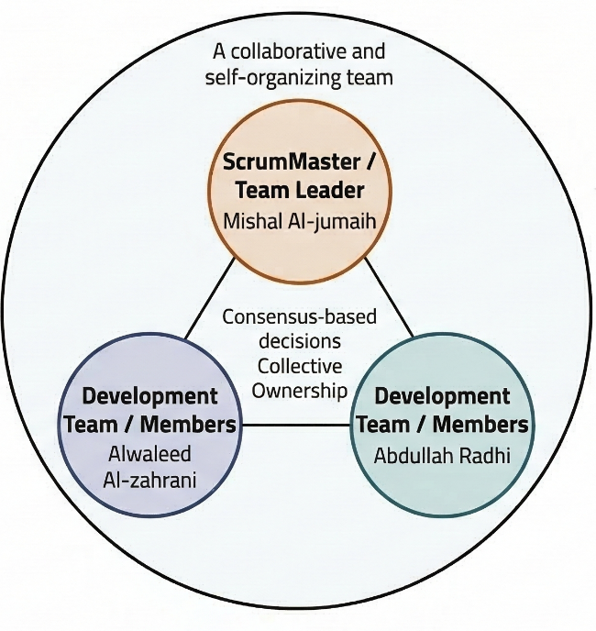
Figure 1:Internal Structure

2.3 Roles and Responsibilities
Our project roles and responsibilities are guided by the Scrum framework. In our project, our Development Team is composed of the three of us, an informal trio of students. In order to ensure that all managerial and technical processes are addressed, we also assign roles for our project as shown below.

Table 3: Project Roles and Responsibilities
# | Team Member Name | Project Role (Scrum) | Primary Responsibilities & Work Activities
1 | Mishal Al-jumaih (Leader) | ScrumMaster & Development member | - Managerial and Technical blend: The ScrumMaster-character facilitates meetings, resolves conflicts, and manages the Agile Sprint. At the same time, a hands-on Full Stack All Rounder gets involved in all coding work, UI/UX design, database work, and testing, with the Agile principle of Collective Ownership in mind
2 | - | Development member | - Technical (Data) and Technical (Design): The Database Admin is in charge of designing and securing the database. Meanwhile, the UI/UX Lead designs the bilingual interfaces to ensure that the product reaches the mark of Usability/Acceptability.
3 | - | Development & Database Admin | - Managerial and Technical synergy: The individual oversees Product Backlog management, defining User Stories, and prioritizing features. On the technical side, the Lead Programmer and UI/UX Developer write the code for the main program and create interfaces for user interaction.

Managerial Process Plans
This section of the Project Management Plan will outline how the project will be managed. This section will include the start-up plan, the plan for handling risks, the plan for doing the work, the plan for tracking progress, and the plan for closing the project.

3.1 Start-up Plan
3.1.1 Estimates
Since the project will be developed with the Agile (Scrum) method, which is the case with the Mizan framework, the estimates will be done with the Story-Based Planning method, as described in Chapter 23, instead of the traditional algorithmic models like COCOMO II. For the schedule, the project will be done in one semester, which equals 16 weeks. For the cost, the project will be done with open-source web development technologies like HTML/CSS/JavaScript for the frontend and PHP/MySQL for the backend, as mentioned in the budget summary section. However, the budget summary requires specific hardware to be included in the project, The estimated budget is ~1706 SAR (covering cloud server, domain, AI tools, and testing hardware) for 5 months.
Confidence Level: Since the project will be done with familiar technologies and will be restricted to the Potentially Shippable Product Increment (PSPI), the estimates will be considered reliable and will be reviewed and adjusted at the end of each sprint, considering the changes in the Agile method.

3.1.2 Staffing
The project team will include 3 students. Since the project will be done as an Informal Group, as recommended in Chapter 22, the decision will be made with consensus, which will encourage team spirit among the team members. Number of Personnel & Skills: 3 student engineers working as the Agile Development Team, each with basic and intermediate knowledge in web development, system development, and testing. Duration of Requirement: This requirement will be valid for the whole academic semester, which equals 16 weeks. Source of Staff: Internal – assigned university students for the BCS 202 course.

3.1.3 Project Staff Training
To build the Mizan web application, we plan to have short periods of self-directed learning and peer mentoring during the first weeks of the project. This is to cater to the "Self-realization" motivation factor by providing all team members with training to enable self-learning. Version Control (GitHub) - Basic training on how to use GitHub to avoid version control problems when aligning front-end and back-end work. Backend Integration - Quick training on how to securely integrate PHP with MySQL to ensure data integrity when handling users’ financial data. Agile Documentation - Quick refresher on how to write User Stories properly and use "effort points" to estimate User Stories.

3.2 Work Plan

Work Breakdown Structure
Project planning is an essential part of software projects. It involves breaking down a software project into parts and allocating each part to team members. To effectively manage the Mizan software project during the semester, we plan to have it broken down into four major iterative phases. This is to cater to the Agile software development method that integrates aspects of specification, design, and implementation.
Phase 1: Project Initiation & Proposal
- 1.1 Project Proposal Discussion & Literature Review
- 1.2 Define Project Scope — Personal Finance Archive System (Mizan)
- 1.3 Set Up Development Environment (XAMPP, MySQL, VS Code, GitHub)
- 1.4 Establish Team Roles — Scrum Master & Development Team Members
Phase 2: Project Planning & Management
- 2.1 Develop Software Project Management Plan (SPMP)
- 2.2 Define Work Breakdown Structure (WBS) & Schedule
- 2.3 Identify Risks and Mitigation Strategies
- 2.4 Submit Status Report 1
Phase 3: Requirements Engineering — Sprint 0
- 3.1 Define User Stories & Product Backlog
- 3.2 Write Software Requirements Specification (SRS)
- 3.3 Identify Functional & Non-Functional Requirements
- 3.4 Submit Status Report 2
Phase 4: System Design & Architecture — Sprint 0
- 4.1 Design Database Schema — 8 Core Tables (users, projects, expenses, warranties, invoices, files, notifications, password_resets)
- 4.2 Design System Architecture — MVC-style PHP Structure with REST API Layer
- 4.3 UI/UX Wireframing — Color Palette, Typography (Tajawal), Dark/Light Mode
- 4.4 Frontend Foundation (style.css, animations.css, main.js)
- 4.5 Write Software Design Specification (SDS)
Phase 5: Authentication & Foundation — Sprint 1
- 5.1 Landing Page (welcome.php) — Canvas animation, bilingual AR/EN, team section
- 5.2 Login & Registration Pages (login.php, register.php)
- 5.3 Password Recovery System (forgot-password.php, reset-password.php)
- 5.4 Logout Page with auto countdown (logout.php)
- 5.5 Header, Footer & Sidebar Navigation (includes/header.php, footer.php)
- 5.6 Dashboard (index.php) — Statistics cards, recent activity feed
- 5.7 Authentication Backend — Session management, password hashing (bcrypt)

Phase 6: Core Features — Sprint 2
- 6.1 Projects Page (projects.php) — Create, search, filter, color-coded cards
- 6.2 Project Detail Page (project-detail.php) - Expenses, Budget Tracking, Progress Bar
- 6.3 Projects & Expenses CRUD API (api/projects.php)
- 6.4 File Upload System (api/upload.php) - 500 MB limit, Drag & Drop Interface
- 6.5 Invoices Page (invoices.php) - Grid View, Preview, Download
- 6.6 Warranties Page (warranties.php) - Countdown Timer, Status Badges (active, expiring, expired)
- 6.7 Files Page (files.php) - Grid/List View Toggle, Multi-Type Support
Phase 7: Notifications & Communication - Sprint 3
- 7.1 Notifications System (api/notifications.php) - Automatic Warranty Expiry Notifications
- 7.2 Notifications Bell in Header - Real-Time Unread Notifications Badge
- 7.3 Email System (config/mail.php) - SMTP, HTML Templates
- 7.4 Email - Password Reset Template
- 7.5 Email - Warranty Expiry Alert Template (30 days, 7 days, 1 day)
- 7.6 Email - Budget Exceeded Alert Template
- 7.7 Email - Welcome New User Template
Phase 8: Advanced Features & Reports - Sprint 4
- 8.1 Reports Page (reports.php) - Chart.js Charts (monthly spend, category donut, budget vs actual spend)
- 8.2 PDF/CSV Export for Reports
- 8.3 Settings Page (settings.php) - User Preferences, Currency, Notifications
- 8.4 Change Password from Settings
- 8.5 Read-Only Share Link per Project
- 8.6 Global Search - Projects, Invoices, Files
- 8.7 Budget Alerts - Notification + Email if Spending Exceeds Budget
- 8.8 Bilingual Support (AR/EN) - Language Persisted in Local Storage
- 8.9 Dark/Light Mode - CSS Variables + Local Storage Theme Persist
Phase 9: Testing & Closure - Sprint 5
- 9.1 Security Audit - XSS, SQL Injection, CSRF Protection
- 9.2 Cross-browser + Mobile Responsive Testing
- 9.3 File Upload + Email Notification Testing
- 9.4 Performance Optimization — Image Compression, Query Tuning, Caching
- 9.5 Deploy to Live Hosting — Hostinger + Namecheap Domain + SSL Certificate + SMTP Activation
- 9.6 Develop User Manual & Technical Documentation — README
- 9.7 Final Report, Project Presentation, and Delivery of the PSPI (Potentially Shippable Product Increment — Mizan Live System)

3.2.2 Schedule Allocation
the schedule allocation and sequencing, we have decided to use an Activity Bar Chart (also known as a Gantt Chart). As mentioned in Chapter 23, bar charts are considered standard project schedule presentation methods. This will give us an idea of our Agile iterations and milestones.
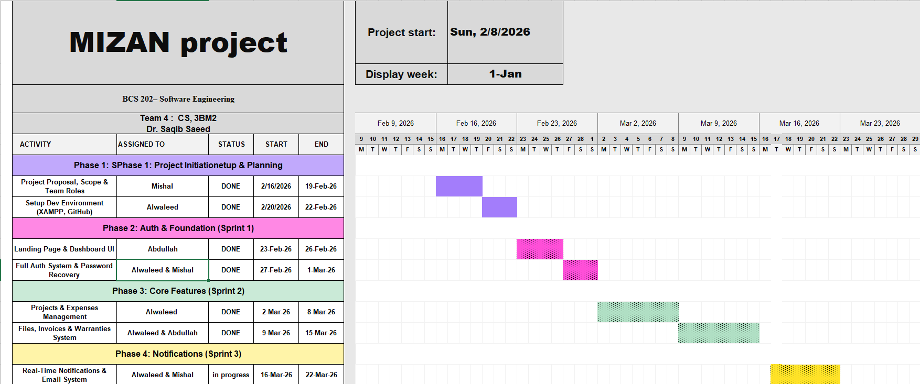
Figure 2: Gantt Chart(weeks 1-6)
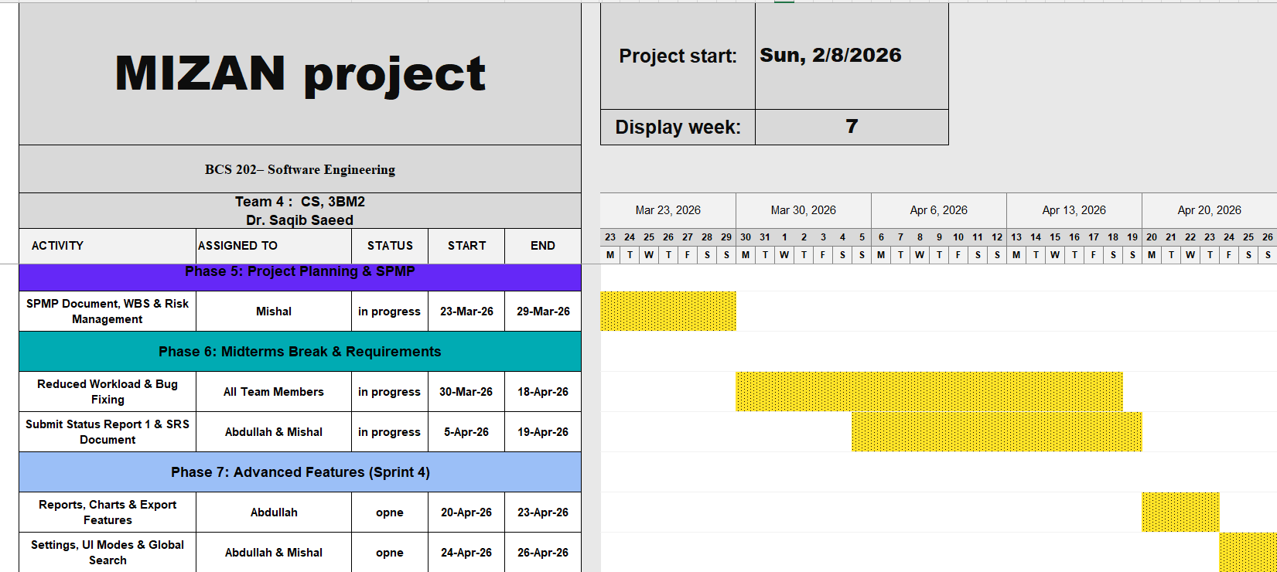
Figure 3: Gantt Chart (weeks -7 -12)

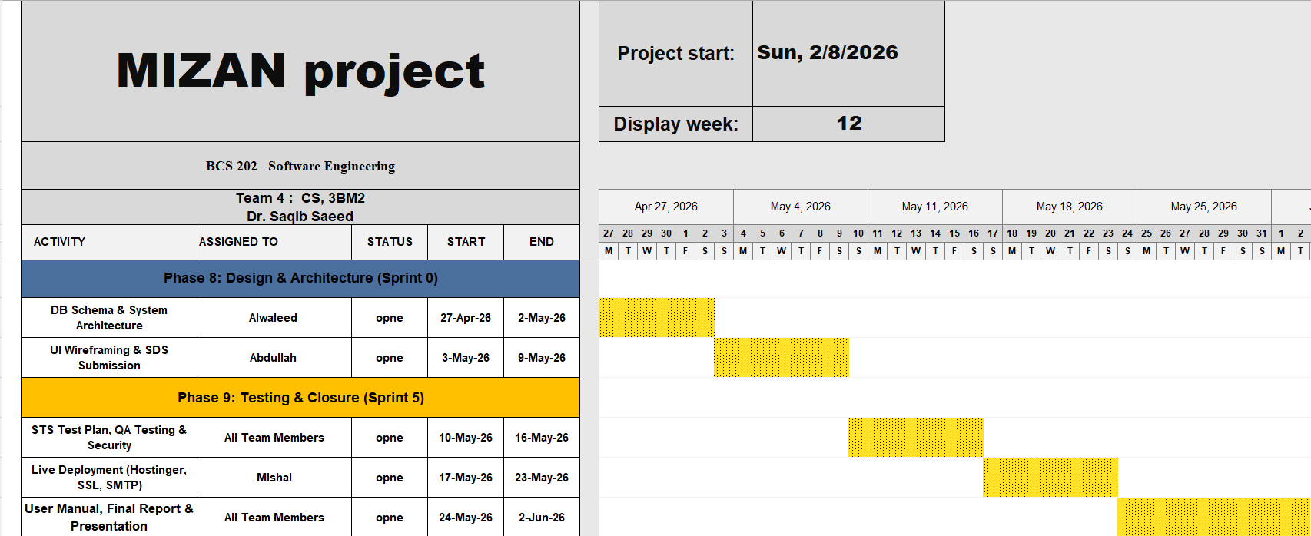
Figure 4: Gantt Chart(weeks 13-16)

3.2.3 Resource Allocation
Our team is composed of three members and can be considered an Agile group. Although there is some degree of role overlap to encourage team ownership of the code, there are still distinct allocations to ensure all activities under the Work Breakdown Structure are efficiently covered.

Table 4:human and hardware resources required per phase
WBS Activity | Primary Human Resource (Scrum Role) | Necessary Tools / Technology & Financial Resources
1. Planning (SPMP) | Mishal (ScrumMaster) & -(Product Owner) | Microsoft Word, GitHub Projects
2. Requirements (SRS & Backlog) | -(Product Owner) | Microsoft Word, Agile Backlog Tool
3. Design (SDS, DB & UI) | All member | Figma, Draw.io, Database Modeling Tools
4. Backend Dev (PHP/MySQL, cPanel Hosting, | - (Lead Programmer) & Mishal (Support) | VS Code, XAMPP, PHP, MySQL  SSL/HTTPS, SMTP Mail
5. Frontend Dev (JS/HTML) | All Team Members | VS Code, JavaScript, HTML, CSS
6. Testing, QA & Deployment | All Team Members | Localhost (XAMPP), Browsers, Cloud Servers & Domain

3.2.4 Budget Allocation
As indicated in our start-up plan, we use open-source tools to reduce costs. However, we also have a budget for the deployment stage to acquire the necessary hardware resources (Cloud Server) and a domain name.
Table 5:a breakdown of the budget for each stage:
Activities | Cost
1. Planning (SPMP) | 0 SAR
2. Requirements (SRS) | 0 SAR
3. Design (SDS & UI) | 0 SAR
4. Backend Dev (PHP/MySQL) | 0 SAR (Local Development)
5. Frontend Dev (JS/HTML) | 0 SAR (Local Development)
6. Testing & QA | -  Cloud Server, Domain, AI Tools & Testing Hardware (~706 SAR)

3.3 Project Tracking Plan

3.3.1 Requirements Management
1. Measuring, Reporting, and Controlling Changes:
As proposed in Chapter 3, Agile principles are followed in accepting changing requirements. Instead of filling in change requests, all project requirements are dynamically managed in a ‘Product Backlog.’ Any change or new requirement is entered as a ‘User Story.’ We manage all changes and requirements by dynamically re-prioritizing our ‘Product Backlog’ before the start of a new ‘Sprint.’
2. Assessing Impact on Scope, Schedule, Budget, and Risks:
We assess all impact areas when there are any changes in the project’s requirements during ‘Sprint Planning. Schedule & Scope: We determine the difficulty level of any ‘User Story’ and then determine ‘effort points’ to assess our team’s ‘velocity.’ If a change is large, it is postponed to a future release to ensure timely completion of our current ‘Sprint.’
Budget & Resources: student-funded budget of ~1706 SAR, which is to be provided by students, and free web tools, any change in requirements does not increase our costs significantly. We assess any change in requirements to determine its impact on our ‘student resources.’
Risks: We assess any new requirement to determine any possible risks to our project or product before implementation.
3. Change Control Board (CCB) Procedures:
As an Agile Informal Group, we do not have a hierarchical change control board. Instead, we have our three members acting as the CCB. We have group consensus during sprint reviews to control changes. We discuss the change, and we determine whether it is necessary for the “Mizan” PSPI (Potentially Shippable Product Increment). We approve or reject it as a group.
4. Traceability, Prototyping, and Reviews:
Traceability: All code changes committed into GitHub are conceptually linked to their corresponding User Story in the backlog and can be traced back to their original requirement.
Prototyping & Modeling: We deal with changing requirements through System Prototyping and incremental deliveries, developing small UI/UX increments to visually validate requirements with the evaluator.
Reviews: We evaluate prototypes and changes during sprint retrospectives to validate them as meeting requirements without compromising software quality.

3.3.2 Schedule Control
Measuring Progress at Milestones:
We use Agile as our project management approach. We can measure our project’s progress at milestones. At minor milestones (i.e., at the end of each sprint), we can track our project’s progress based on the number of completed and tested user stories. At major project milestones (i.e., at project milestones where we deliver SPMP, SRS, and software), we can track our project’s progress based on the successful submission and approval of project deliverables.
Comparing Actual vs. Planned Progress:
In our daily stand-ups (Scrums) and Sprint Retrospectives, we compare actual progress with what was planned. For example, if in our last Sprint we had planned to complete 10 User Stories and only completed 7, it is immediately apparent and discussed.
Corrective Action:
When actual progress deviates significantly from the plan (for example, if we fall behind in our progress), we take corrective action. Like in Agile planning, we do not extend the delivery period. Instead, we reduce the scope of our current Sprint by removing lower-priority User Stories and moving them back into the original backlog. This way, we ensure that our PSPI is delivered within the original timeframe.
Tools and Methods for Schedule Control:
For our schedule progress control, we will use a digital Kanban board (GitHub Projects). Tasks will flow through columns: To Do, In Progress, and Done.
Objective Criteria for Evaluation:
For measuring our progress in terms of scope and quality at each minor milestone (Sprint), we will use the Agile Definition of Done. A User Story is considered "Done" if: its frontend UI is complete (HTML/CSS), its backend logic is connected (PHP/MySQL), and it was reviewed and accepted by another team member.
The provided image is a visualization of the Scrum Agile framework, an iterative and incremental approach to managing and developing products. It showcases the key roles, artifacts, and events within a Scrum process, highlighting the cyclical nature of development sprints. The visual flow begins with the Product Owner and progresses through various stages, culminating in a continuous cycle of product development and improvement.

Figure 5:Scrum Agile Framework
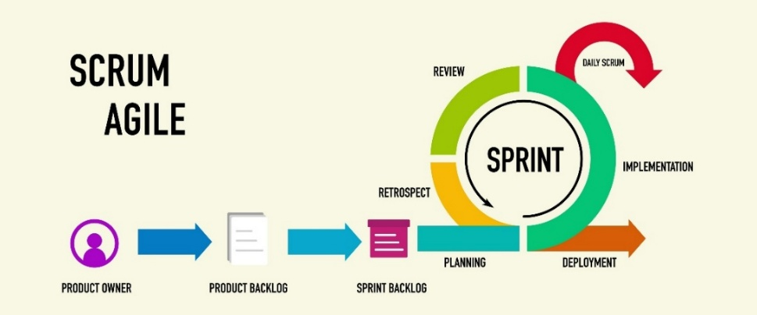
Product Owner
The Scrum process starts with the Product Owner, represented here by a purple icon. The Product Owner is responsible for maximizing the value of the product resulting from the work of the development team. This role is crucial as they define the product vision and manage the product backlog.
Transition to Product Backlog
A large blue arrow indicates the flow from the Product Owner to the next major artifact. This represents the Product Owner's primary responsibility of creating and maintaining the product backlog.
Product Backlog
The Product Backlog is depicted as a document icon. This artifact is a prioritized list of all the features, functions, requirements, enhancements, and fixes that constitute the changes to be made to the product in future releases. It is a dynamic and living document that evolves as the product and its environment change.

3.3.3 Quality Control
1. Measuring and Controlling the Quality of Work Products: To ensure the final web application meets the "Dependability" and "Efficiency" standards required for software, quality is measured continuously during our Agile Sprints. Every software feature (User Story) must satisfy a strict "Definition of Done" before it is considered a completed and acceptable work product.
2. Quality Assurance of Conformance to Work Processes: To ensure the team is strictly conforming to our chosen Agile (Scrum) process, the designated Scrum Master (Team Member 1) will monitor daily activities. This includes ensuring that the Product Backlog is always updated, Sprint Planning meetings are held, and the Kanban board reflects the true status of the HTML/PHP development tasks.
3. Verification and Validation (V&V): Verification (Are we building the product right?): This is conducted through mandatory peer code reviews. For example, when the Frontend Lead writes the UI code (HTML/CSS), another team member must review the code for errors or vulnerabilities before merging it into the main GitHub branch.
Validation (Are we building the right product?): This is conducted by testing the working UI prototypes against the initial User Stories. We validate the idea that the system successfully solves the user's "data silo" problem by correctly grouping tasks and costs.
4. Joint Reviews: Instead of traditional formal review gates, the team holds a "Sprint Retrospective" (Joint Review) at the end of every 2–4-week Sprint. During this meeting, the entire three-member team evaluates the working software increment, discusses any bugs found, and agrees on quality improvements for the next Sprint.
5. Audits and Process Assessment: Because we are a university student team operating as an "Informal Group" (Chapter 22), formal external audits are not applicable. Instead, they are replaced by internal Process Assessments conducted during our weekly meetings. The team assesses our own Agile workflow, identifies any communication bottlenecks, and adjusts our process to improve collaboration and code quality.

3.3.4 Reporting
1. Reporting Mechanisms, Formats, and Information Flows:
Internal Communication (Within the Project): Information is exchanged horizontally among team members. Instead of administrative reports, we use a digital Kanban board and Daily Scrums as our reporting tool. Since we have all team information on the digital board, we don’t have to say anything. The status of requirements, schedule, and quality is automatically updated as task cards move on the board.
External Communication (To Entities External to the Project): Information is exchanged vertically with entities above us. Hence, we use formal written reports such as SPMP, SRS, Final Presentation submitted as PDF or Word documents to report major milestones and quality of work.
2. Methods, Tools, and Techniques of Communication:
Techniques: We use an Agile method of Daily Scrum or Stand-up Meetings. Team members assemble to update each other on work progress from the previous meeting to the current meeting and plan to work during the next meeting.
Tools: GitHub Projects to visualize metrics and task status and WhatsApp or virtual meeting software such as Zoom to hold virtual team meetings and Sprint Planning Meetings.
3. Frequency and Detail of Communications
As we continue to adhere to our student-focused project scope and our budget of about 1706 SAR, we adjust our frequency and level of detail in our communications to remain efficient and productive without stalling our project’s progress.
Frequency: Internal stand-ups are held every week.
Formal reports to external stakeholders are done in compliance with academic milestones (e.g., Week 8 and Week 16).
Detail: Internal communications are brief and rich in technical content, focusing on specific problems in our PHP/HTML codes and risks.
Formal reports to external stakeholders are of high-level content, discussing general information about our project management, budget (within our 1706 SAR budget), and our milestone achievements.

3.3.5 Project Metrics
1. Methods, Tools, and Techniques for Collecting and Retaining Metrics
As we adhere to our agile methodology, our metrics collection is also agile and light to keep our project’s progress moving smoothly.
Methods & Techniques: We will utilize our agile methodology to track our Product Backlog completion and our bugs during peer reviews.
Tools: GitHub Projects would automatically display our tasks’ progress.
Excel or Google Sheets would contain our historical log of our metric data collected throughout our Sprints.
2. Metrics Process Information
Metric 1 (Schedule/Scope): Sprint Velocity - Total User Stories moved to Done in a Sprint.
Metric 2 (Quality): Defect Count - bugs or errors in our PHP/MySQL backend and our HTML frontend during verification and testing.
Frequency of collection: We collect our metrics every end of iteration (every 2 to 4 weeks) during our Sprint Retrospective. Validation, analysis, and reporting:
Validation: ScrumMaster (Mishal) verifies the actual User Stories implemented against code committed to GitHub.
Analysis: Sprint Velocity is used to estimate how much work is feasible in the next Sprint; Defect Count helps identify problematic modules (e.g., DB connection) that may require rewriting.
Reporting: Internal Sprint Retrospectives for metrics; Midterm and Final Reports for the instructor.

3.4 Risk Management Plan
1. Risk Identification, Analysis, Prioritization, and Assessment
Identification & Assessment:
Risks are initially identified as constraints of the project (3 students, 16 weeks, ~1706 SAR budget) and technology stack (PHP/MySQL/Cloud Deployment). Risks will be constantly assessed through Agile Sprint Planning events.
Analyzing & Prioritizing:
Risks will be analyzed and prioritized according to their probability and impact. Risks with high probability and impact will be placed at the top of the Product Backlog for prompt treatment.
2. Risk Management Procedures, Activities, and Schedules
Contingency Planning: In case of occurrence of any of the identified risks (e.g., technical issues), reduction of project scope is our first option: reduce UI features to deliver the backend.
Tracking, Evaluating, and Responding: Risks will be monitored through weekly evaluation of their levels in Weekly Stand-ups. In case of rising risk levels, tasks with low priority will be moved to the next Sprint.
Activities & Schedules: Activities related to risk management will be aligned with Agile events: Weekly Stand-ups, Sprint Planning, and Sprint Retrospectives.
3. Documentation, Organization, and Communication
Documentation & Reporting: Risks will be documented in the Risk Register and formally presented in Midterm and Final Reports for the instructor.
Organization & Personnel: Risks will be collectively managed by all team members (3 persons). ScrumMaster (Mishal) is in charge of maintaining the Risk Register.
Communication: Internal status is displayed on the Kanban board and group chat, whereas external status is sent to the instructor via scheduled project reports. Subcontractor communication is not applicable for this scenario.
4. Applicable Impact of Specific Risk Factors
Customer Project Risks: The customer for this project is the instructor. The greatest customer project risk is misinterpreting assignment requirements, which may impact the final grade. Mitigation: Early start of UI prototyping.
Contractual Risks: N/A. This is a student-funded university project with an estimated budget of ~1706 SAR.
Technological Risks: The greatest technological risk is the learning curve for integrating HTML frontend with PHP/MySQL backend and cloud deployment, which may impact the schedule. Mitigation: Test database connections in Sprint 0.

Table 6:Risk Management Register (Risk Log)
ID | Potential Risk | Category | Probability | Impact | Effects
1 | Misinterpreting Assignment Requirements | Customer-Project | Medium | High | Negative impact on the final academic grade and project acceptance.
2 | Integration Learning Curve | Technological | High | High | Delayed schedule due to difficulties connecting HTML/JS frontend with PHP/MySQL backend and Cloud deployment.
3 | Midterm Examinations Period | Schedule / Resource | High | High | Severe slowdown in coding progress due to academic pressure on the 3 team members.
4 | Exceeding the Budget | Financial | Low | Medium | Inability to deploy the final live system (PSPI) on the cloud server.

3.5 Project Closeout Plan
1. Product Transition and Delivery
As this is a university project, the final working increment of the PSPI will be packaged for delivery to the instructor. The transition includes:
1) Pushing the final and stable code to the main branch of the team’s GitHub repository.
2) Developing a setup guide (Readme) that includes how to configure the local database with XAMPP and includes the live Cloud Server URL for running and testing the web application.
2. Administrative Closeout:
In this step, we will conclude all project management and documentation. This will involve finalizing all aspects of the project. This is a comprehensive list of all the steps to be taken:
Complete and submit the finalized SPMP, SRS, and SDS documents via the university’s academic portal.
Prepare and present the final presentation slides to showcase the system’s "Unified Entry" features.
3. Post-Mortem and Lessons Learned:
In keeping with our Agile development methodology, we will hold one final Sprint Retrospective meeting after completing all steps in the previous steps. This will involve lessons learned from our experience working with PHP/MySQL, working in an Agile team, and time management, which will be included in our final report.

4. Technical Process Plans

4.1 Process Model
1.Process Model Selection & Tailoring: For the software development process, the team has chosen a customized Agile development process. Since the team consists of only three members, the team is considered small. In this case, the team has chosen the Scrum framework because it is a subset of the Agile methodology. The major differences are the use of a weekly meeting instead of the daily meeting and the use of instructor approval instead of client approval. The development sprints are scheduled for 5 sprints and will take 16 weeks, ranging from February 1 to June 2nd, 2026.
2. Project Initiation & Termination:
- Initiation: Submitting the project proposal (February 1st), requirements gathering, setting up the development environment (XAMPP, MySQL, VS Code, GitHub), and developing the basic tools and database schema.
- Termination: Uploading the code onto GitHub, deploying the application onto the live server (Hosting+ SSL), and submitting the final report and presentation by May 17th – June 2nd, 2026.
3. Flow of Information & Relationships:
User requirements are entered into the Product Backlog. In the case of the Sprints, the highest priority requirements are entered into the Sprint Backlog and implemented as working software increments for the application Mizan. The code is reviewed by peers before it is pushed onto the main branch in GitHub.
4. Baselines, Milestones, Timing & Deliverables: Development of the project Mizan occurs incrementally in a period of 11 weeks with 5 sprints.
- Baseline 1 (Weeks 1-3): Initiation & Planning Deliverables: Project Proposal, SPMP, Setup of the development environment.
- Baseline 2 (Weeks 4-6): Core Implementation – Sprint 1 & 2 Deliverables: Implementation of the authentication system, implementation of the dashboard, implementation of the projects & expenses module, implementation of the file upload system.
- Baseline 3 (Weeks 7-8): Requirements & Advanced Features – Sprint 3 Deliverables: SRS, Status reports 1 & 2, implementation of the notifications & email system, implementation of the reports module.
- Baseline 4 (Weeks 9-14): Design & Testing – Sprint 4 & 5 Deliverables: SDS, STS test plan, implementation of the settings page, implementation of the security audit, live deployment.
- Baseline 5 (Week 14-16): Release Deliverables: Mizan PSPI (Potentially Shippable Product Increment), final report, final presentation.

5. Reviews & Approvals:
- Reviews: Internal peer code reviews, Agile sprint retrospectives, security audit.
- Approvals: Formal grading and approval of the project by the instructor of the course after the end of each baseline, approval of the SPMP, approval of the SRS, approval of the SDS, approval of the STS, approval of the final project submission.
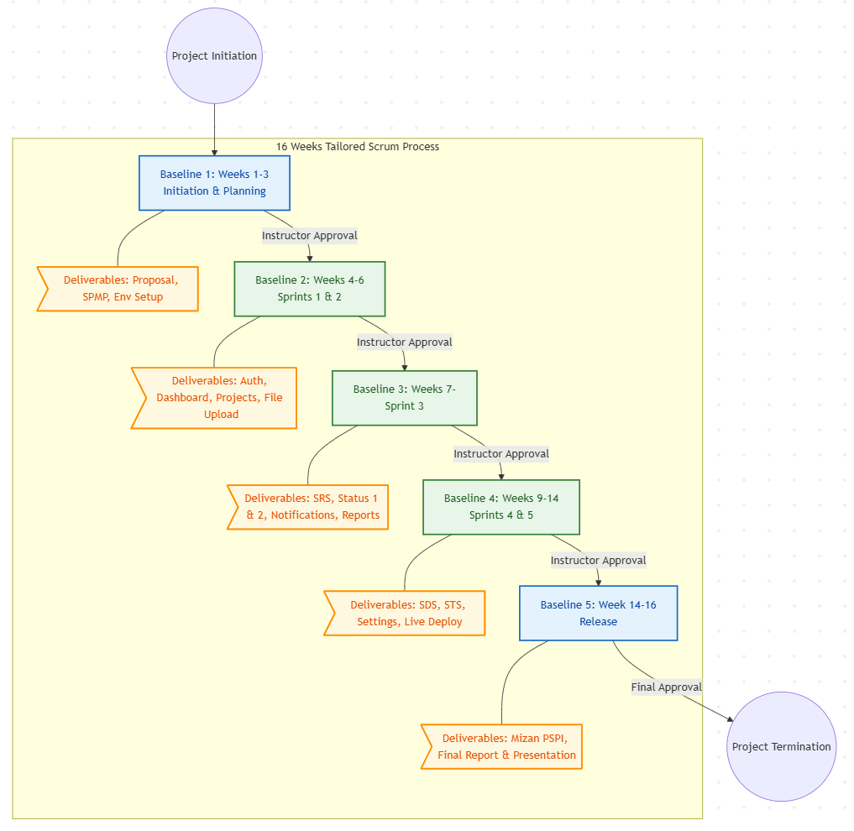
Figure 6:Baselines & Deliverables
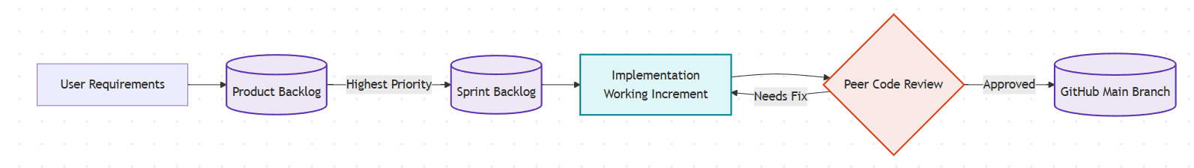
Figure 7:Flow of Information

4.2 Methods, Tools, and Techniques
1. Development of Methodologies, Languages, and Tools:
Methodology: Agile (Scrum).
Languages: HTML/CSS/JavaScript (Frontend) and PHP 8/MySQL (Backend).
Design Tools: Figma (UI) and Draw.io (Database UML).
Build & Test Tools: Visual Studio Code (IDE), XAMPP (local testing server), Flatpickr , SweetAlert2, Chart.js, AI Assistants (Claude Pro & Google AI Pro) for code refinement, and an external Huawei Tablet for cross-device system testing.
Integration & Delivery: Git and GitHub for version control, cPanel Hosting, SSL/HTTPS, SMTP Mail, and Cloud Web Hosting for final delivery.
2. Technical Standards, Policies, and Procedures:
Coding Standards: All HTML and PHP files must be properly formatted, and complex SQL queries must include explanatory comments.
Procedures: Commit code to GitHub at the end of each working session.
Policies: A mandatory peer review is required. One team member must test another member’s code before it is merged into the main branch to satisfy the Agile “Definition of Done.”

4.3 Infrastructure
With our ~1706 SAR budget, the team combines existing student resources with appropriate hardware and software to construct and maintain the development environment.
1. Hardware, Operating Systems, and Network: Hardware & OS: Each team member will use their own laptop for development, running Windows or macOS. An external Huawei Tablet will be set aside for System Testing, ensuring maximum Usability across devices.
Network: Internet and GitHub syncing will be done over personal or university LAN/Wi-Fi.
2. Software Tools: We will use free and open-source software for analysis, designing, development, and project management, such as Figma, VS Code, cPanel, XAMPP, and GitHub.
Advanced AI assistants like Claude Pro and Google AI Pro will be heavily utilized to accelerate the development process.
3. Facilities, Security, and Administration: Facilities: Development and meetings will be done in university library study rooms or at home, providing collaborative workspaces for the team.
Physical Security: Password protection on personal laptops and university access will ensure security.
Administrative & Janitorial: Not applicable (N/A) to the student-scale project.

4.4 Product Acceptance
1. Customer Acceptance Plan & Objective Criteria:
Acceptance Plan: The final deliverables will be accepted by the instructor through academic milestones and a final live presentation.Acceptance Criteria: Acceptance of deliverables is determined if all key User Stories for the Unified Entry software are implemented, if the PHP/MySQL backend works without fatal database errors, and if the software works successfully in the live Cloud Server environment (PSPI).
2. Formal Agreement: As it is a student project in a university setting, it is not applicable to create a corporate IT contract. Instead, it is accepted in accordance with the syllabus grading rubric and acceptance of the Software Requirements Specification (SRS) by the instructor.
3. Technical Processes, Methods, and Tools:
The acceptance of deliverables will be verified through the following Verification and Validation (V&V) techniques:
Demonstration: A live walkthrough of the web application’s functionalities during the final evaluation.
Testing: Manual testing of the front and back ends of the web application using standard web browsers in the live Cloud Server.
Inspection: Inspection of the source code of the project in GitHub and the submitted PDF/Word documents (SPMP, SRS, SDS)

5. Supporting Process Plans

5.1 Documentation
To ensure proper tracking of the project and academic requirements for compliance with software engineering principles and practices, it is recommended that essential documents be created. Table 6 shows the documentation plan in accordance with our Agile team roles.

Table 7:the documentation plan in accordance with our Agile team roles.
Document Name | Controlling Template / Standard | Prepared By (Primary) | Reviewed By
Software Project Management Plan (SPMP) | IEEE Std 1058 | Mishal (ScrumMaster) | All Team Members
Software Requirements Specification (SRS) | IEEE Std 830 / Agile Backlog | - (Product Owner) | All Team Members
Software Design Specification (SDS) | Standard UML / ERD Formats | - (DB Admin & UI Lead) | All Team Members
User Manual (README) | GitHub Markdown Standard | Mishal (ScrumMaster) | All Team Members

6. Additional Plans
As Mizan is a university-level student project, we don’t have any large-scale corporate-level data conversion and transition plans. Nevertheless, we have formulated a number of additional plans to meet the basic product requirements:
1. Security and Privacy Plan: For basic security and privacy, our PHP-based application will adhere to standard web security practices to meet the Dependability attribute. We will implement prepared SQL statements to prevent SQL injection attacks and also securely hash user passwords before storing them in the MySQL database.
2. Product Installation Plan: Our app is designed to live in the cloud. We are providing this plan to our instructor, who will then provide the live mizan-app.com URL to our evaluator, which is covered in our budget. We are also adding a detailed README to our GitHub repository that will guide our evaluator on how to install XAMPP and then our PHP-based application in case of a disaster or a backup scenario.
3. User Training Plan: As our bilingual interface is user-friendly in nature, there is no need to provide any formal training to our users. We are also adding a brief electronic user manual and a live demo of our application during our final project presentation.
4. Maintenance, Support, and Transition Plans: As this is a 16-week academic-level project, there is no need to provide any long-term maintenance, special equipment specifications, transition, or support (N/A). We are ending our project support when our instructor grades our application at the end of this semester.

